WGVABC Treasury Report
September 6, 2016

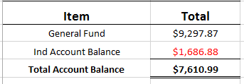

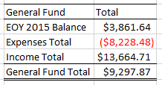
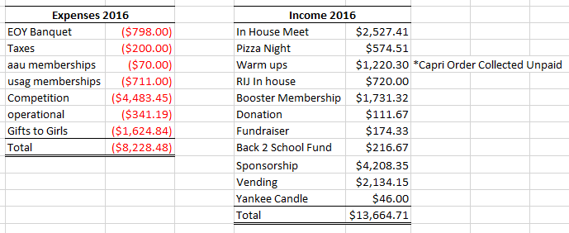

*Vending Machine Purchase $2385 owed 6 months to pay 0% interest

